**Safety First with UV Light**

**New Control of Artificial Optical Radiation at Work Regulations 2010, brought into law in Great Britain on 27th April 2010, the occupational UV light exposure limits specified by the EU Optical Radiation Directive 2006/25/EC …. MAKE SURE YOUR COMPANY COMPLIES!**

|  |
| --- |
| **Synopsis**  This article is intended to provide an insight into the new regulations, creating awareness and assisting those responsible for the health and safety of persons exposed to UV light in the workplace, to identify their duties and possible obligations to revise existing risk assessments under the Management of Health and Safety at Work Regulations 1999. |

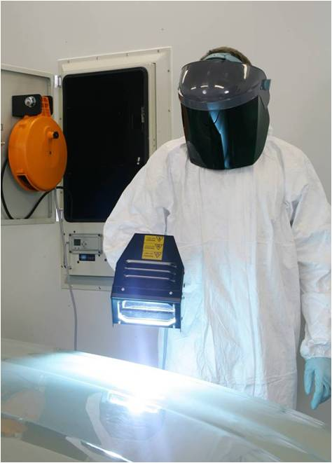UV lamps are extensively used throughout industry for UV curing, exposure and quality control of a wide variety of materials. Many workers exposed to artificial UV light sources are increasingly concerned about risks to their health and safety. This is often a result of media coverage concerning the potential detrimental effects of UV light from natural sunlight and sunbeds, which has lead to widespread misinformation and misunderstanding regarding UV light exposure in the workplace.

Occupational UV light exposure in Great Britain is now subject to the new Control of Artificial Optical Radiation at Work Regulations 2010, which brought into law the European Physical Agents (Artificial Optical Radiation 2006/25/EC) Directive. This incorporates statutory UV light exposure limit values (ELV’s) which became law on 27th April 2010. It specifies the minimum health and safety requirements for protection of workers from risks arising from exposure to UV light and provides clarity on precisely what is required for safe use of UV light in the workplace.

It states that employers must determine personal UV light exposure levels and compare with the exposure limit values as a means of assessing risk and necessary controls. Workers must not be exposed above the exposure limit values and must be provided with specific information and training.

Ensuring compliance with the UV light exposure limits by appropriate control measures and providing appropriate information and training will not only mean that employers meet their obligations, but will build confidence and acceptance of safe working practices by the workforce.

There are different UV light exposure limit values depending on the wavelength range of the UV lamp. It should also be noted that more than one exposure limit value may apply for a specific wavelength range. It is therefore necessary to understand the definition and classification of UV light and know the wavelength range of the UV lamp in order to identify the applicable exposure limit value.

**What is UV Light?**

UV light is non ionising electromagnetic radiation, transmitted in the form of waves, which are described by their wavelength and measured in nanometres (nm). It is located between the blue end of visible light and x-rays (400nm to 100nm) and split into the following spectral range classification bands:-

UV-A 400nm to 315nm - UV-B 315nm to 280nm - UV-C 280nm to 100nm

ERSTable

Please note:-

1nm = 1 millionth of a millimetre.

The term ‘optical radiation’ defines the region of the electromagnetic spectrum which includes UV, visible and infrared light.

UV light energy and therefore potential to cause adverse health effects is inversely proportional to wavelength across the bands. The dividing lines between the bands are convenient distinctions and not boundaries where sudden, large changes occur in detrimental health effects. The potential to cause damage to unprotected skin and eyes varies across the bands and classification is therefore only a broad indication of the effectiveness for producing adverse health effects.

UV-A has the lowest energy and least potential to cause acute adverse health effects.

UV-B has significantly higher energy and greater potential to cause acute adverse health effects than UV-A.

UV-C has highest energy and generally the most potential to cause acute adverse health effects.

The exposure limit values take the lower limit of the UV-C region to be 180nm. This is because UV light below 180nm (vacuum UV) is readily attenuated in air and is therefore of little practical biological significance.

It is well established and generally agreed, that low level exposure to certain wavelengths of UV light provides some health benefits, for example synthesis of vitamin D3. On the other hand, over exposure to UV light can cause adverse health effects, such as erythema (sunburn), photoconjunctivitis and photokeratitis (arc eye) in the short term (acute effects) and can be attributed to premature skin ageing, skin cancer and cataracts, as a result of repeated exposure in the long term (chronic effects).

The levels of risk for acute adverse health effects is determined by UV light wavelengths present, UV light irradiance values and personal exposure time.

**The key is to avoid over exposure to UV light in the workplace and this necessitates the strict implementation of exposure limit values.**

**UV Light Exposure Limit Values (ELV’s)**

The Control of Artificial Optical Radiation at Work Regulations 2010 and the Optical Radiation Directive is based on exposure limit values defined by the International Commission on Non-Ionising Radiation Protection (ICNIRP).

In cases of persons subjected to UV light exposure from artificial sources, it is necessary to assess the level of risk for adverse health effects by determining personal UV light exposure levels and comparing with the exposure limit values.

Where personal exposure complies with the exposure limit values, the risk can be considered low for the majority of the population and adequately controlled so far as is reasonably practicable. In addition workers must be provided with specific information and training.

Where personal exposure exceeds the exposure limit values, then additional control measures must be implemented which decrease exposure to below the exposure limit value.

The UV light exposure limit values (ELV’s) for a broadband source are defined below.

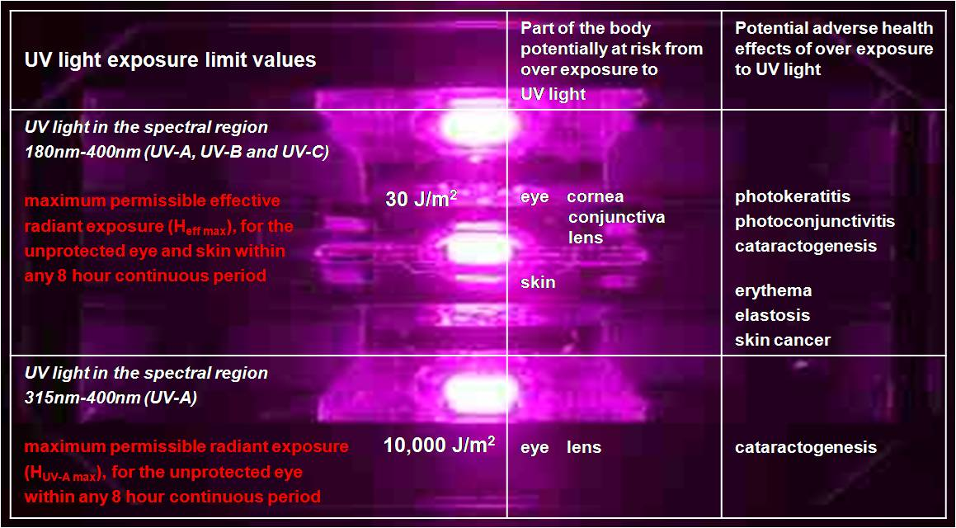

The exposure limit values define a level of UV light exposure, below which nearly all individuals may be repeatedly exposed without adverse acute health effects and incorporate significant safety margins.

**The maximum permissible effective radiant exposure value (Heff max) of30 J/m2** takes into account variations of different UV light wavelengths in causing biological hazardous effects such as, erythema, photoconjunctivitis and photokeratitis. This is necessary because some UV light wavelengths have a very significant effect, others a proportionally less effect and some almost none at all, depending on the effect in question. It provides a measurement which is weighted by wavelength according to a spectral weighting function (Sλ) which is directly proportional to the biological hazardous effect.

**The maximum permissible UV-A light radiant exposure value (HUV-A max) of 10,000 J/m2** is an unweighted value and is in addition to the above.

It is necessary that compliance is achieved with both exposure limit values detailed above. This is achieved by adopting the most restrictive exposure limit for the eye.

**Determination and Assessment of Personal UV Light Exposure Levels**

***The crucial question is ….. can a clear and unambiguous statement be made that the UV light exposure limit values are either observed or exceeded?***

**Use of Manufacturers Data**

Where the operating instructions for a UV lamp provide the type of data illustrated below in Figure 1, then this will allow determination of personal exposure scenarios for assessing compliance with the exposure limit values. This is the most user friendly way of presenting data for ease of operator understanding and risk assessment. **It allows a clear and** **unambiguous statement to be made that the UV light exposure limit values are either observed or exceeded.**

|  |  |  |  |  |
| --- | --- | --- | --- | --- |
| uv250-held | **UV 250W Hand Lamp**  **fitted with Fe bulb and**  **UV-A black filter glass** | | | **New-UVLogo** |
| **Distance from front of**  **UV 250W hand lamp**  **(mm)** | | **Maximum permissible UV light exposure time**  **within any continuous 8 hour period** | | |
| **unprotected eye**  **tUV-A max** | **unprotected skin and eye**  **teff max** | |
| **100** | | **41.89 seconds** | **14.25 minutes** | |
| **500** | | **7.87 minutes** | **2.67 hours** | |
| **1000** | | **25.21 minutes** | **8.9 hours** | |
| This data is only applicable to the UV 250W hand lamp fitted with an Fe bulb and UV-A black filter glass supplied by UV Light Technology Limited.  **Please Note:**  Many surfaces, especially those that are smooth and/or highly reflective and/or light coloured, are often good reflectors of UV light. In a situation where a person is located behind or outside a UV light beam shining directly at a highly reflective surface, the simplest way to determine the maximum permissible exposure times is by using the distance from the UV lamp to the reflective surface and back to the person. This method will automatically introduce an additional safety margin due to reflective losses. | | | | |

**Figure 1 -** Maximum permissible UV light exposure times for the unprotected skin and eye in any continuous 8 hour period, at various distances within the beam of the UV 250W hand lamp

It is necessary for duty holders to limit personal UV light exposure time at the specified positions above, to ensure that the maximum permissible exposure values for the unprotected skin and eye are **NOT EXCEEDED** within any 8 hour continuous period. If the maximum permissible exposure values are exceeded then the UV light irradiance must be reduced by appropriate control measures. These could include containment, moving further away from the UV light source, reducing exposure time, or as a last resort provision of personal protective equipment (PPE).

**UV Light Measurements**

**However, if this information is not available, a clear and unambiguous statement cannot be made that the exposure limit values are either observed or exceeded.** In this case UV light irradiance measurements will most likely need to be made, to assess whether or not exposure to a particular UV lamp would cause a person, located in a specific position, to exceed either of the exposure limit values. This requires specialist measurement equipment, knowledge and expertise.

Generally, two separate UV light irradiance values, **Eeff** (W/m2) and **EUV-A** (W/m2), must be measured at appropriate distances from the UV lamp.

Maximum permissible exposure times (**teff max** and **tUV-A max**) at the measurement positions can then be calculated as follows:

|  |  |  |  |
| --- | --- | --- | --- |
|  | Heff **max** 30 J/m2 |  | **HUV-A****max**10,000 J/m2 |
| **teff max** = | _____________ | **tUV-A max** = | __________________ |
|  | **Eeff**(W/m2) |  | **EUV-A**(W/m2) |
|  | (measured value) |  | (measured value) |

Where:

|  |  |  |
| --- | --- | --- |
| **Symbol** | **Description** | **Units** |
| **Eeff** | measured value of UV light effective irradiance – this is UV light irradiance within the wavelength range 180nm - 400nm (UV-A, UV-B, UV-C) spectrally weighted by Sλ | W/m2 |
| **Sλ** | biological spectral effectiveness – this is the relative spectral effectiveness of UV light wavelengths present for producing adverse health effects on the unprotected eye and skin |  |
| **EUV-A** | measured value of UV-A light irradiance within the wavelength range 315nm - 400nm | W/m2 |
| **teff max** | maximum permissible exposure time to UV light within the wavelength range 180nm - 400nm (UV-A, UV-B and UV-C) spectrally weighted by Sλ incident upon the unprotected skin or eye | s |
| **tUV-A max** | maximum permissible exposure time to UV light within the wavelength range 315nm - 400nm incident upon the unprotected eye | s |
| **Heff max** | maximum permissible UV light effective radiant exposure incident upon the unprotected skin or eye | J/m2 |
| **HUV-A max** | maximum permissible UV light radiant exposure incident upon the unprotected eye | J/m2 |

**where teff max  > tUV-A max**

Maximum permissible exposure time for the skin and eye is longer than the maximum permissible exposure time for the eye.

In order to comply with both ELV’s the shortest maximum permissible exposure time for the eye is adopted and therefore in this case there are separate maximum permissible exposure times for the skin and eye. This is the case with the UV 250W hand lamp example provided in Figure 1.

**where tUV-A max  > teff max**

Maximum permissible exposure time for the eye is longer than the maximum permissible exposure time for the skin and eye.

In order to comply with both ELV’s, the shortest maximum permissible exposure time for the eye is adopted and therefore in this case tUV-A max is disregarded and there is only one maximum permissible exposure time for both skin and eye. This is the case with the UV 250W hand lamp example provided below in Figure 2.

|  |  |  |  |  |
| --- | --- | --- | --- | --- |
| Picture 012 | **UV 250W Hand Lamp**  **fitted with Fe bulb and**  **clear UV-A+B filter glass** | | **New-UVLogo** | |
| **Distance from front of**  **UV 250W hand lamp**  **(mm)** | | **Maximum permissible UV light exposure time**  **within any continuous 8 hour period** | |
| **unprotected eye**  **tUV-A max** | **unprotected skin and eye**  **teff max** |
| **100** | | **21.93 seconds** | **3.47 seconds** |
| **500** | | **4.8 minutes** | **36.59 seconds** |
| **1000** | | **16.03 minutes** | **2 minutes** |
| This data is only applicable to the UV 250W hand lamp fitted with an Fe bulb and clear UV-A+B filter glass supplied by UV Light Technology Limited.  **Please Note:**  Many surfaces, especially those that are smooth and/or highly reflective and/or light coloured, are often good reflectors of UV light. In a situation where a person is located behind or outside a UV light beam shining directly at a highly reflective surface, the simplest way to determine the maximum permissible exposure times is by using the distance from the UV lamp to the reflective surface and back to the person. This method will automatically introduce an additional safety margin due to reflective losses. | | | |

**Figure 2 -** Maximum permissible UV light exposure times for the unprotected skin and eye in any continuous 8 hour period, at various distances within the beam of the UV 250W hand lamp.

**Specific Information and Training**

All persons who have the potential to be exposed to UV light which could cause adverse health effects to the eye or skin must be provided with suitable and sufficient information and training. Subjects covered must include:

* The exposure limit values and potential adverse health effects of over exposure to UV light on their eyes or skin.
* Results of determination and assessment of personal UV light exposure levels with an explanation of significance and potential risk. It is important that the risks are put in perspective.
* Control measures and safe working practices to minimise the risk.
* Heightened photosensitivity.
* Entitlement to appropriate health surveillance where necessary.
* Detection of adverse health effects, reporting procedures and entitlement to medical examination where necessary.
* Necessary pre-operational checks to UV light equipment, for example, where a filter glass is fitted in front of a UV bulb, always ensure it is intact and securely mounted in the correct position.

**UV light cannot be seen or felt, therefore it is important that workers are regularly reminded.**

**Enhanced Photosensitivity**

The UV light exposure limits may not be adequate protection for photosensitive individuals and special precautions may be necessary. These individuals should seek medical advice with respect to additional protective measures which may be required before any exposure to UV light.

***Heightened Individual Susceptibility***

Check that all persons who could be exposed to significant levels of UV light are not unusually photosensitive, exposed to photosensitising agents, or less commonly aphakic or pseudophakic persons. This can be done by using questionnaires.

- Individuals who are intrinsically photosensitive are normally aware of their heightened sensitivity.

- Individuals who are exposed to photosensitising agents, either ingested, injected or externally applied, may not be aware of their heightened sensitivity.

Examples of chemical compounds which enhance photosensitivity are:

|  |  |
| --- | --- |
| Antibiotics | e.g. tetracyclines |
| Tranquillisers | e.g. phenothiazines, especially chlorpromazine |
| Diuretics | e.g. thiazides |
| Sulphonamides | e.g. sulphamethoxazole with trimethoprim |
| Hypnotics | e.g. phenobarbitone |
| Antibacterials | e.g. nalidixic acid |
| Coal tar and creosote | |
| Some cosmetics, due to presence of eosin or psoralens | |
| Various plants such as carrot, celery, dill, fig, lemon and some types of weeds | |

These may enter the body by ingestion, injection or absorption through the skin. The speed of effect and severity of symptoms depends on the route of entry.

***Heightened Collective Susceptibility***

Check for any possible effects on the health and safety of employees which could result from the interaction between UV light exposure and photosensitising chemical substances.

**Conclusion**

The case for using UV lamps for material curing, exposure and testing applications is compelling. This is because UV light applications can represent cutting edge technology, providing innovative new product and process developments, often providing improved productivity, reduced costs, lower solvent emissions, better quality and in some cases exciting new business opportunities.

It is essential therefore that UV light is continued to be used within industry for material processing and quality control. Whilst we must accept that there are risks associated with all human activity, UV light exposure at levels which comply with the new Control of Artificial Optical Radiation at Work Regulations 2010 will help ensure that risks are low and adequately controlled.

**About the Author**

A Metallurgy and Materials Technology graduate of the University of Aston in Birmingham, Paul Jackson has 23 years experience in UV light technology and is a widely respected and senior player in this relatively youthful industry.

He has been called upon as an expert during litigation involving personal UV light exposure and is a regular conference speaker. In addition he has published a book and runs training courses entitled ‘*Safety First with UV Light’.*

Paul Jackson is Managing Director of UV Light Technology Limited, The Light House, 582-584 Hagley Road West, Birmingham B68 0BS, UK.

Tel: +44 (0)121 423 2000. Fax: +44 (0)121 423 2050.

Email: [sales@uv-light.co.uk](mailto:sales@uv-light.co.uk) Web: [www.uv-light.co.uk](http://www.uv-light.co.uk)

**About UV Light Technology Limited**

The company manufacturers UV light equipment for an increasingly broad spectrum of industrial, medical, scientific, security and public service applications. Thousands of companies worldwide are using their equipment every day including many for material curing, exposure and testing applications.

It has always been UV Light Technology Limited’s first priority to ensure they meet all current and known future health and safety requirements. This year is particularly important in this respect, with the new Control of Artificial Optical Radiation at Work Regulations 2010.

The company is offering the following training courses during 2010 in order to provide information to help companies and organisations to meet their obligations for the safe use of UV light in the workplace.

**Health and Safety Training Course**

**Safety First with UV Light**

A one day course aimed at Health and Safety professionals and those responsible for ensuring the safe use of UV light in the workplace.

It is designed to provide information to help employers meet their obligations for the safe use of UV light equipment and to gain the confidence and acceptance of the workforce.

It covers risk assessment and control of personal exposure to UV light in the workplace, in compliance with the new Control of Artificial Optical Radiation at Work Regulations 2010.

Dates confirmed for this year are:-

Thursday, 10th June 2010, Thursday, 21st October 2010

We can also conduct this course on your site - details on request.

**Operator Training Courses**

**Safety First with UV Light**

A half day course designed to provide the information to help operators safely use UV light equipment for their particular application and to gain their confidence and acceptance.

Details on request.

All UV Light Technology Limited equipment is supplied with comprehensive operating instructions. These include maximum permissible UV light exposure times for the unprotected skin and eye at specified distances from the UV lamp. This enables strict compliance with the new EU rules, defined by the Optical Radiation Directive 2006/25/EC which was brought into law in Great Britain on 27th April 2010 by the Control of Artificial Optical Radiation at Work Regulations 2010.